 CHEMICAL ENGINEERING TRANSACTIONS  VOL. , 2025 | A publication of  
The Italian Association
of Chemical Engineering
Online at www.cetjournal.it

Guest Editors: Laura Piazza, Francesco Donsì, Giorgia Spigno
Copyright © 2025, AIDIC Servizi S.r.l.
ISBN 979-12-81206-19-9; ISSN 2283-9216

3D Layer-by-Layer Printing of Protein-Based Soft Solid Foods: Challenges and Potential for Dysphagia Foods
Laura Piazza^{a,}*, Marco Menegonª, Francesca Girottoª, Giorgio Innocenzo Ascrizziª
ª Università degli Studi di Milano, Department of Environmental Science and Policy, 20133, Milan, Italy
* laura.piazza@unimi.it

This study explores the application of additive manufacturing in developing foods suitable for individuals with mild to moderate swallowing difficulties (IDDSI levels 4-5). Functional extrusion-based 3D printing inks were designed and optimized for layer-by-layer fabrication using a 3D food printer. Two protein-rich ink formulations were developed: one containing commercial pea protein and the other based on sonicated lab-extracted sunflower proteins, obtained from micronized press cake upcycled from sunflower seed oil extraction. High- or low-acyl gellan gum, xanthan gum, sorbitol, and NaCl were incorporated to fine-tune viscoelasticity and flow behavior, ensuring precise control over the printed multilayer structures. Key techno-functional properties of the proteins, including emulsifying and water-holding capacities, were evaluated as critical parameters for printability. Inks rheology was characterized by using the Herschel-Bulkley model to describe flow behavior, while the Bohlin power-law model quantified viscoelastic properties from dynamic mechanical spectra. The pea protein-rich ink exhibited the highest yield stress, indicating greater structural integrity and printability. Both inks behaved as weak gels with soft-solid structures, but the pea protein ink displayed higher gel strength and a higher structural coordination index, correlating with increased elasticity and suitability for constructing robust printed structures. The extrusion process was carried out at 60 °C. Square grid structures (20×20×10 mm, 20% infill) were successfully printed to evaluate printability and structural stability. After post-printing stabilization, mechanical properties of the printed objects were assessed via uniaxial compression tests. The printed objects maintained their shape post-stabilization without collapsing. Compression tests confirmed the pea protein-based ink’s superior printability, as indicated by: i) sufficiently high elastic modulus to support its own weight and maintain layering; ii) high yield stress, enabling precise filament deposition while allowing for smooth extrusion; iii) greater structural cohesion, preventing deformation during printing; iv) pronounced strain softening, meaning the material gradually deforms, contributing to a chewier sensation before breakdown during oral processing. Overall, higher elasticity and structural cohesion in the pea protein ink resulted in greater printing precision and improved suitability for 3D-printed foods tailored to individuals with dysphagia.
  - Introduction
Additive manufacturing (AM) techniques have experienced rapid growth over the past decade, offering numerous possibilities for producing multifunctional, complex structures. Among these, extrusion-based 3D printing, also known as Direct Ink Writing (DIW) or layer-by-layer 3D printing, provides a unique approach to integrating advanced, high-value materials into scalable manufacturing processes. Complex structures are first designed using Computer-Aided Design (CAD) software and then transferred to a program that controls the robotic printing system. The ink is deposited through a nozzle, layer by layer, until the desired shape is fully constructed.
The use of 3D printing technology for producing edible soft foods has gained popularity in recent years due to its potential benefits, including the ability to customize food design for personalized nutrition and the development of healthcare foods with embedded mechanical or rheological properties (Lorentz et al., 2022). A wide range of recommendations for food colloidal and hydrogel-based ink formulations can be found in the literature. However, quantifying the criteria that define printability remains challenging for soft materials with complex viscoelastic properties. Controlling the rheological properties of formulations is essential for effective 3D printing. It is generally recognized that printable formulations must be shear-thinning, yield-stress soft materials exhibiting solid-like behavior.
This study marks a first step toward developing customized 3D-printed protein-based soft-solid foods with tailored textures, specifically designed for individuals with oral processing impairments, such as swallowing difficulties. A major challenge in 3D printing these materials is optimizing their formulation to achieve the right viscoelasticity and flow behavior for both extrusion and shape retention. To overcome printability challenges, ink formulations have been carefully designed, incorporating gelling and thickening agents to enable precise control of multilayer structures. Mechanical and rheological analyses, including oscillatory and shear tests, were conducted to establish optimal printability protocols. The study examined a commercial pea protein concentrate and a lab-produced sunflower protein concentrate, the latter upcycled from the residual press cake of industrial sunflower seed oil extraction. These proteins were assessed for their techno-functional properties, which play a crucial structural role in ink formulations and printed foods.
  - Materials and Methods
    - 3D printing procedure
A pressure-controlled, syringe-type extrusion 3D printing system (Procusini® Research 3D Food Printer, Freising, Germany) which adopts a layer-by-layer deposition technique to build computer-aided designed objects was used. The printer is equipped with a heating system to maintain the temperature of the formulation in the syringe and nozzle. Slicer software was used to set the printing conditions, such as temperature, nozzle diameter, layer height, and extruder moving speed. The syringe heating temperature was 60 °C and the layer height was 1.2 mm. The 3D modelling software Fusion 360 (v2.0.20981, Autodesk 2024) was used to design the 3D object to be printed, a square grid geometry with dimensions of 20×20×10 mm and a 20% infill level.
    - Food inks formulations
Food inks were formulated using lab-made sunflower protein concentrate (10%) or commercial pea protein concentrate (10%), xanthan gum (up to 2%), sorbitol (up to 10%), high-acyl or low-acyl gellan gum (up to 2%), and NaCl (up to 1%). The ingredient’s concentrations were varied to optimize the ink printability. A key step in the ink preparation process was heating to 85 °C for 3 minutes to allow gellan gelation.
Sunflower proteins were obtained at the laboratory scale from dehulled sunflower press-cake (DSPC), supplied by Savi Italo S.r.l. (Fiorenzuola d’Adda, Piacenza, Italy). DSPC was first micronized using a milling device (KMX-500 ultra-fine, Separ Microsystem, Italy) to reduce particle size <700 µm. Proteins were then extracted chemically at their isoelectric point (pI; pH 4), followed by neutralization and freeze-drying using (lyophilizer LIO-5PDGT Kambič d.o.o., Semič, Slovenia). Probe ultrasonication was eventually performed using a sonicator (Fisherbrand, FB505EUK-220, Waltham, USA) working at the frequency of 20 kHz, amplitude of 48 µm for 4 minutes (Girotto et al., 2025). Pea protein concentrate (PPC) was provided by Cargill Inc. (Minneapolis, USA). High-acyl (HA), low-acyl (LA) gellan gums and xanthan gums were provided by CP Kelco (Atlanta, USA). Sorbitol was purchased from Sigma-Aldrich (St. Louis, USA).
    - Analyses of ingredients, inks and printed objects
As for the protein ingredients, the techno-functional properties of water holding capacity (WHC) (Malomo et al., 2014), emulsion capacity (EC), and emulsion stability (ES) (Siddiq et al., 2009) were assessed. Analyses of total solids (TS), ashes and proteins on DSPC and PPC were performed according to the methods described by AOAC (2000). Tests were performed in triplicate.

The flow behavior of the optimized inks was studied through shear flow tests using a CMT rheometer (DHR-2, TA Instruments, USA), equipped with a 40 mm diameter cone-plate geometry. Dispersions were subjected to shear deformation within the shear rate range 0.1-100 s⁻¹ at 60 °C. The flow index and the yield stress were calculated applying the Herschel-Bulkley model (Equation 1) which describes the flow behavior of non-Newtonian fluids, especially those that exhibit yield stress:
$σ=σ_{0}+ k⋅{γ ̇}^{n}$ (1)
where $σ$ is the shear stress (Pa), $σ$₀ is the yield stress (Pa), $k$ is the consistency index (Pa·s^{n}), γ̇ is the shear rate (s⁻¹) and n is the flow behavior index (dimensionless).
Viscoelastic properties of the optimised inks were detected at 60 °C, using a CMT rheometer (DHR-2, TA Instruments, USA), equipped with a 40 mm diameter plate-plate geometry. A strain sweep test was conducted in the range of 0.01-100% strain at 1 Hz and a frequency sweep test was performed from 0.1 to 100 Hz, within the linear viscoelastic region. Mechanical spectra (G’, G” (Pa) vs frequency (Hz)) were analysed through software TRIOS 3.0.2 (TA Instruments, USA). The Bohlin power law model (Equation 2), that is validated for weak gels, was used to quantify the viscoelastic behavior (Gabriele et al., 2001) of the inks:
$G^{*}=\sqrt{{G^{'}}^{2}+{G^{''}}^{2}}=A_{f}ω^{1∕z}$ (2)
where G* is the complex modulus (Pa), $A_{f}$ is the gel strength, ω is the angular frequency, and coefficient Z is the degree of interaction.

Mechanical properties of the printed objects were assessed after post-printing stabilization at 4 °C overnight using a TA-XT2 texture analyzer (Stable MicroSystems Ltd, Godalming, UK) equipped with a 75 mm diameter disk geometry. Mechanical tests were performed at room temperature (21 °C). A uniaxial compression test was carried out until 70% deformation at test speed equal to 1 mm/s (Hussain et al., 2021). From the force/distance curve, the following parameters were evaluated: elastic modulus (Pa), yield stress (kPa), specific deformation energy (kJ/m³). The reported results are the average of three replicates for each sample.
    - Statistical analysis
Statistical analysis was performed using JMP Pro version 18.0 (SAS Institute Inc., Cary, NC, USA). Data were subjected to one-way analysis of variance (p<0.05), and mean differences among samples were evaluated using the HSD Tukey-Kramer test.
  - Results and Discussion
By optimizing print quality, precision and mechanical properties of printed objects can be enhanced while reducing defects like warping and rough surfaces. Optimization is particularly crucial when utilizing various protein-based raw materials as functional inks in extrusion-based, layer-by-layer 3D food printing. Key challenges include achieving the appropriate viscosity and flow behaviour, as protein-based inks that are too runny or too stiff can either clog the printer or result in unstable structures. Additionally, structuring and emulsifying properties of proteins are essential for successful printing, which directly impacts texture and printability. Water-holding capacity also plays a vital role, as excessive or insufficient moisture retention can compromise the uniformity of multilayer structures, hinder shape retention, or lead to the collapse of printed objects over time. Finally, post-printing storage remains a significant technical challenge, as maintaining shape, texture, and overall safety is essential for the final product's quality and usability.
To overcome these challenges, the protein-based ink formulations that were here developed include a blend of gelling and thickening agents, enabling precise control over multilayer structures. Table 1 shows different techno-functional properties of protein ingredients used to formulate inks with a protein content equal to 10% w/w: commercial pea protein concentrate, and lab-produced sunflower protein concentrate subjected to either probe sonication or no sonication.
Table 1: Sunflower (DSPC) and pea (PPC) protein concentrates: chemical analysis and function properties
 | TS  (%) | Ashes  (%) | Proteins  (%) | WHC (gH₂O/g) | EC  (%) | ES  (%)
Sunflower protein  concentrate | 98.99 ± 0.03 ª | 3.87 ± 0.09 ^{b} | 72.61 ± 0.66 ^{b} | 0.92 ± 0.01^{b} | 58.8 ± 1.8 ^{b} | 37.0 ± 0.6 ^{c}
Sonicated Sunflower protein  concentrate | / | / | / | 0.78 ± 0.09 ^{b} | 63.8 ± 1.8 ^{b} | 43.4 ± 0.7 ^{b}
Pea protein concentrate | 93.53 ± 0.16 ^{b} | 5.31 ± 0.07 ª | 78.95 ± 1.54 ª | 2.50 ± 0.03 ª | 73.8 ± 1.8 ª | 62.6 ± 2.3 ª
TS: total solids; WHC: water holding capacity; EC: emulsion capacity; ES: emulsion stability. For each column, different lowercase letters indicate significant differences (p<0.05).

Pea proteins exhibited superior emulsifying properties and significantly higher water-holding capacity (WHC), improving hydration properties and structural integrity, compared to both sunflower protein concentrates. A high WHC protein facilitates a smooth, continuous flow during printing, minimizing the risk of nozzle clogging. Moreover, higher WHC helps the printed structure maintain its shape, preventing collapse due to excessive water release. It also reduces the likelihood of excessive drying, preserving the texture and quality of the final product. Protein concentrates used in formulation determine the fat content of inks, low for pea (~0.2-0.4%, estimated) and moderate for sunflower (~0.5-1.0%, estimated). Sunflower proteins used in the study benefit from ultrasound (US) treatment, as sonicated samples show increased emulsifying capacity (EC) and emulsion stability (ES), leading to better dispersion and stability, but lowering WHC. Sonication is expected to cause partial unfolding of proteins, exposing hydrophobic regions that enhance interaction with the lipid phase, thereby improving emulsification, with statistical difference. At the same time, the interaction with water molecules decreases due to the reduced exposure of hydrophilic groups.
Due to the above-mentioned techno functionalities and because of a broad starting set of formulation trials, DSPC-probe sonicated (US-DSPC) and PPC were finally selected for inks design.

To overcome printability challenges, ink formulations here developed including a blend of gelling and thickening agents, to enable precise control over multilayer structures. Both high-acyl (HA) and low-acyl (LA) gellan gum were evaluated for their physical and functional properties in inks. Results on rheological behavior of the gellan gums are not reported in the paper and are under publication. The main conclusion is that the gelation of the two differs due to the structural variations in their molecular composition. HA Gellan forms soft, elastic, and flexible gels which tend to exhibit a "chewy" texture with high water retention, whereas LA gellan gum forms firm, brittle, and rigid gels that are more prone to fracture under stress. It is well known that gellan gum gelation is ion-dependent and typically requires counterions to facilitate crosslinking. LA gellan gum exhibits a gelation temperature between approximately 30 and 40 °C in the presence of ions, forming gels stable at elevated temperatures that generally resist melting. On the other hand, HA gellan gum has a gelation temperature around 60-70 °C and a reversible gel-sol transition. To conclude, LA gellan was chosen for gel rigidity, suitable for layered gelled foods and to avoid thermoreversibility.
Sodium ion (Na⁺) was chosen as counterion. Being monovalent, it can partially shield the negatively charged carboxylate groups on the gellan backbone. This reduces electrostatic repulsion between gellan molecules, allowing them to come closer and form a gel network. The gel formed in the presence of sodium ions is weaker and less rigid compared to gels formed with divalent cations and this is a texture property suitable for dysphagia oriented printed soft foods.
Inks rheology and printability can be further modulated by addition of xanthan gum. Xanthan gum and LA gellan gum can interact synergistically in aqueous solutions, forming a stronger and more elastic gel than either gum alone. When combined, xanthan helps modify gellan’s gel properties, making it more elastic and less brittle while still maintaining gel strength. As has been reported (Szczesniak & Farkas, 2006), xanthan is definitively expected to improve mouthfeel, the texture appreciated in the mouth.
Finally, sorbitol is included in the ink formulations because of its humectant and plasticizer role. It helps retain moisture by maintaining a smooth texture; it can reduce brittleness in the gel structure and finally sorbitol has a mild sweetness that could contribute to flavor balance.
In Table 2 viscosimetric and viscoelastic parameters of inks, which determine how well the material can be extruded and maintain its shape after deposition, are shown. The tests were run at the printing temperature (60 °C).
 | Inks |  |  |  |  | Printed objects
Protein type in inks | n | k  (Pa·s^{n}) | $σ$₀  (Pa) | $$A_{f}$$  (Pa) | Z | Elastic modulus  (Pa) | Yield  stress  (kPa) | Specific  deformation energy  (kJ/m³)
Sonicated Sunflower protein  concentrate | 0.10 | 88.45 | 51.35 | 27169.35 | 5.16 | 722.93  ± 30.62 ^{b} | 27.97  ± 2.73 ^{b} | 20.00  ± 2.50 ª
Pea protein concentrate | 0.09 | 155.72 | 103.55 | 150108.23 | 5.47 | 853.22  ± 54.03 ª | 35.10  ± 3.50 ª | 21.25  ± 1.25 ª
Table 2: Viscosimetric and viscoelastic parameters for inks and mechanical parameters from compression test on 3D-printed objects
For each column of 3D-printed objects, different lowercase letters indicate significant differences (p<0.05).

Flow curves were modelled by means of the Herschel-Bulkley Eq(1) that applies to shear thinning materials. The yield stress ($σ$₀), the consistency index (k) and the flow behavior index (n) were calculated for the two inks under study. In the context of soft materials for extrusion-based 3D printing, the yield dictates the transition between solid-like and fluid-like behavior. High yield stress prevents spreading or sagging after deposition, allowing layers to stack. The highest yield stress is exhibited by the pea protein-rich ink. The enhancement effect might be attributed to the stronger interaction between gellan and the pea proteins which increased the intensity of the gellan-PPC network structure under pH of 7.4.

Mechanical spectra were evaluated to quantify the viscoelastic behavior of the inks. The resulting mechanical plots are characteristic of hydrogel properties, indicating that both inks behave as weak gels, as evidenced by the storage modulus (G') exceeding the loss modulus (G'') across the entire investigated frequency range. Additionally, a clear frequency dependence of the moduli is observed. For weak gels, mechanical spectra are typically described using the Bohlin power-law model Eq(2), which characterizes the relationship between frequency and the material's viscoelastic properties. In weak polymer gels, $A_{f}$ values depend on the polymer type, crosslinking, and concentration. The calculated values indicate that the inks exhibit a weakly crosslinked structure, behaving as an intermediate between an elastic solid and a structured fluid. 𝐴f is higher for the pea protein ink, suggesting greater mechanical resistance. The $A_{f}$ value (150108 Pa) is relatively high but still plausible, reflecting the stiffness induced by interactions between the pea protein and LA gellan. Regarding the structural coordination index (Z), both polysaccharide-protein hybrid gels exhibited soft-solid structures, forming a weakly crosslinked yet cohesive network. The higher Z coefficient in the power-law exponent for pea protein ink correlates with increased gel elasticity indicating its suitability for constructing a robust printed structure. Considering the pH values of the two inks, 7.4 for sonicated pea protein ink and 6.6 for sunflower protein ink, the latter is closer to its isoelectric point, making Na⁺ counterions crucial in regulating gellan-protein interactions and preventing potential gel brittleness. In the pea protein ink, sodium ions shield negative protein charges, reducing electrostatic repulsion and enhancing interactions with gellan. At pH 6.6, sunflower proteins are already near their isoelectric point, making them prone to aggregation. Sodium further stabilizes this aggregation, resulting in a more compact gel. The pea protein-rich ink is definitively expected to deliver better printability.

Before the final testing section, various printer parameters were tested to handle inks with varying levels of precision: material flow and extrusion control were optimized since soft filaments are prone to over-extrusion and deformation; print speed was selected (10 mm/s) to help prevent misalignment; layer height (1.2 mm) allowed to improve detail. A square grid geometry with a 20% infill level and a final object height of 1 cm was chosen for printing. Printer hardware parameters like nozzle diameter (optimized for 1.5 mm), print bed adhesion, and nozzle positioning were also fine-tuned. Figure 1 shows examples of the 3D objects that were printed, a square grid geometry with dimensions of 20 × 20 × 10 mm and a 20% infill level.

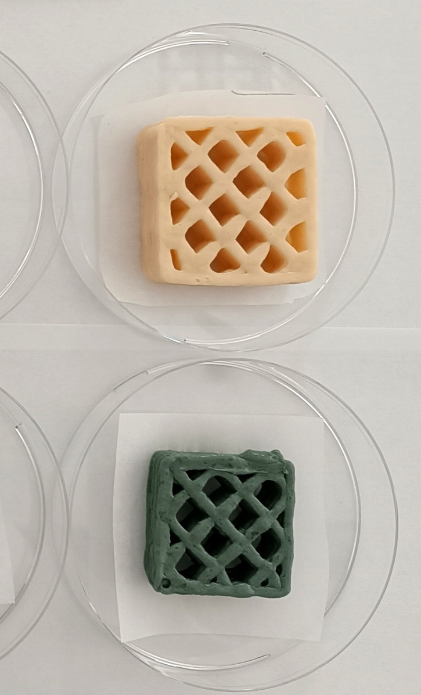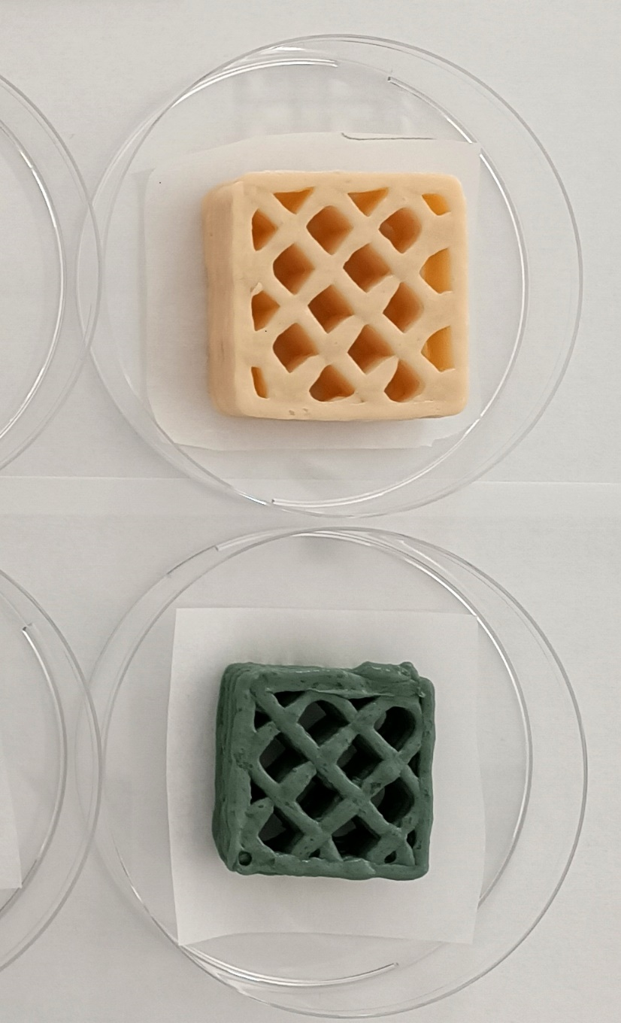
Figure 1: 3D layer-by-layer printed objects from pea protein-rich ink (left) and probe sonicated sunflower protein-rich ink (right).
Mechanical compression tests were run at ambient temperature at the compression rate equal to 1mm/s up to 70% strain on printed objects that were let to rest at overnight 4 °C in a sealed jar, the results are presented in Table 2. The 3D specimens go through an elastic deformation first, with elastic modulus equal to 722.93 ± 30.62 Pa and 853.22 ± 54.03 Pa for US-DSPC and PPC inks, respectively; then yield at 36% strain and 45% strain for US-DSPC and PPC inks, respectively, and yield stress is equal to 27.97 ± 2.73 kPa and 35.10 ± 3.50 kPa for US-DSPC and PPC inks, respectively. A strain softening follows and finally densification begins around 60% strain with a rapid increase in stress with further increase in strain. The Specific deformation energy, i.e., the amount of energy absorbed per unit volume up to 70% level of strain, is equal to 20.00 ± 2.50 kJ/m³ and 21.25 ± 1.25 kJ/m³ for US-DSPC and PPC inks, respectively. The highest Young's modulus of the object that was printed with the pea protein-rich ink, indicates higher stiffness/rigidity.
The two printed materials exhibited different behaviors in terms of strain softening. In compression testing, the elastic component can decrease as the gel deforms, leading to strain softening. This effect is particularly evident when the gel undergoes large strains. A material with more pronounced strain softening, such as that obtained from ink containing pea protein, deforms more gradually in the strain softening region. In terms of oral processing, this behavior can be perceived as a greater sensation of "chewiness" before complete breakdown.
When compression continues beyond the strain-softening region, the material may enter a densification stage, where its structure becomes more compact since the network of polymer chains or particles becomes more tightly packed, reducing its volume. The higher Specific deformation energy value observed in the sample printed with pea protein-based ink indicates greater structural cohesion, suggesting a more robust polymer network. The mechanical properties of the printed objects, therefore, reflect the viscoelastic behavior previously quantified for the protein-based inks in terms of precision in printability and structural integrity/shape retention after printing. The yield stress must be sufficient to retain printing resolution during filament deposition while still allowing for smooth extrusion.
  - Conclusions
Structured foods often provide greater benefits than commercial purée-like meals for individuals with oral processing and swallowing impairments, still far from severe dysphagia (requiring IDDSI Level 4, or lower), where fully smooth purées may still be necessary to minimize choking risk. Soft but structured foods also break down in a controlled manner, whereas thin purées can spread unpredictably. This preliminary study highlights 3D printing as a promising approach for creating customized, sustainable, and texture-adaptable care foods. Nevertheless, challenges remain in ink formulation and process optimization, requiring further research to unlock the full potential of this technology.
3D-printed model foods have been presented that were printed from inks with specific rheological properties that are essential for successful printing and use: moderate viscosity ensuring the food is not too runny while remaining moist enough for easy swallowing; appropriate yield stress that allow for precise layer-by-layer printability and ensure the food resists flow under light pressure but deforms when greater force is applied in the mouth; controlled elasticity since excessive elasticity could make swallowing more difficult.
In conclusion, this study establishes the foundation for developing foods suitable for individuals with mild to moderate swallowing difficulties (IDDSI levels 4-5). Future work should focus on optimizing formulation strategies to enhance ink printability and tailor the texture of layer-by-layer 3D-printed objects.
Acknowledgments
The study was funded under the National Recovery and Resilience Plan (NRRP), Mission 4 Component 2 Investment 1.3-Call for proposals No. 341 of 15 March 2022 of Italian Ministry of University and Research funded by the European Union-NextGenerationEU, Award Number: Project code PE00000003, Concession Decree No. 1550 of 11 October 2022 adopted by the Italian Ministry of University and Research, CUP D93C22000890001, Project title “ON Foods-Research and innovation network on food and nutrition Sustainability, Safety and Security-Working ON Foods”.
References
Association of Official Analytical Chemist (AOAC)., 2000. Official methods of analysis of the association of official analytical chemists international (17th ed.), Gaithersburg: AOAC International.
Girotto F., Ceccanti C., Narra F., Piazza L., 2025. Investigating the suitability of sunflower press-cake proteins in formulated sport beverages. Food & Function, 16, 1992-2003.
Hussain, S., Arora, V.K., Malakar, S., 2021. Formulation of protein‐enriched 3D printable food matrix and evaluation of textural, rheological characteristics, and printing stability. Journal of Food Processing and Preservation, 45(2), e15182.
Siddiq, M., Nasir, M., Ravi, R., Dolan, K.D., Butt, M.S., 2009. Effect of defatted maize germ addition on the functional and textural properties of wheat flour. International Journal of Food Properties, 12(4), 860-870.
Gabriele, D., de Cindio, B., D’Antona, P., 2001. A weak gel model for foods. Rheologica Acta, 40, 120-127.
Malomo, S. A., He, R., Aluko, R.E., 2014. Structural and functional properties of hemp seed protein products. Journal of food science, 79(8).
Lorenz, T., Iskandar, M.M., Baeghbali, V., Ngadi, M.O., Kubow, S., 2022. 3D Food Printing Applications Related to Dysphagia: A Narrative Review. Foods, 11(12):1789.
Szczesniak, A., & Farkas, E. 2006. Objective characterization of the mouthfeel of gum solutions. Journal of food science. 27, 381-385.

